

**CHEMISTRY**

**UNIT 1**

**2016**

**MARKING GUIDE**

**Section One: Multiple-choice (50 marks)**

|  |  |  |  |  |  |  |  |
| --- | --- | --- | --- | --- | --- | --- | --- |
| 1 | a □ b □ c ■ d □ |  | 11 | a □ b ■ c □ d □ |  | 21 | a □ b ■ c □ d □ |
| 2 | a ■ b □ c □ d □ |  | 12 | a ■ b □ c □ d □ |  | 22 | a □ b ■ c □ d □ |
| 3 | a □ b □ c ■ d □ |  | 13 | a □ b ■ c □ d □ |  | 23 | a □ b □ c □ d ■ |
| 4 | a ■ b □ c □ d □ |  | 14 | a □ b □ c □ d ■ |  | 24 | a □ b ■ c □ d □ |
| 5 | a □ b □ c □ d ■ |  | 15 | a □ b □ c ■ d □ |  | 25 | a □ b ■ c □ d □ |

|  |  |  |  |  |  |  |  |
| --- | --- | --- | --- | --- | --- | --- | --- |
| 6 | a □ b ■ c □ d □ |  | 16 | a □ b □ c □ d ■ |  |  |  |
| 7 | a □ b □ c □ d ■ |  | 17 | a □ b □ c ■ d □ |  |  |  |
| 8 | a □ b □ c ■ d □ |  | 18 | a □ b □ c □ d ■ |  |  | (2 marks per question) |
| 9 | a □ b ■ c □ d □ |  | 19 | a ■ b □ c □ d □ |  |  |  |
| 10 | a □ b □ c ■ d □ |  | 20 | a ■ b □ c □ d □ |  |  |  |

**Section Two: Short answer (70 marks)**

**Question 26 (4 marks)**

Complete the following by giving the name or formula for the following:

1. SO2 **Sulfur dioxide**
2. Ammonium sulphite **(NH4)2SO3**
3. AlPO4 **Aluminium phosphate**
4. Hydrogen carbonate ion **HCO3-1**
5. CuCl **Copper (I) chloride**
6. Dinitrogen pentoxide **N2O5**
7. CF4 **Tetrafluoro methane**
8. Calcium nitrate **Ca(NO3)2**

**Question 27 (4 marks)**

Draw an atom of lithium. Label the major regions and the sub-atomic particles.

* **Major regions (nucleus and electron cloud) labelled correctly – 1 mark**
* **Correct number of electrons (3) and labelled in the correct position – 1 mark**
* **Correct number of protons (3) and labelled in the correct position – 1 mark**
* **Correct number of neutrons (4) and labelled in the correct position – 1 mark**

**Question 28 (4 marks)**

State all of the observations that would be seen for the following reactions below. If no observations can be seen, write “no visible reaction”.

(a) An aqueous solution of potassium nitrate is added to a test tube of aqueous barium chloride. (2 marks)

**No visible reaction.**

(b) Propene is added into a test tube of a liquid bromine and shaken. (2 marks)

**Red solution decolourises.**

**Question 29 (4 marks)**

Write balanced ionic equations for the following reactions described below.

(a) An aqueous solution of iron (III) chloride is mixed with an aqueous solution of sodium hydroxide. (2 marks)

**Fe+3 + 3OH-1** 🡪 **Fe(OH)3**

(b) A spatula of solid silver carbonate is added to an aqueous solution of magnesium nitrate. (2 marks)

**Ag2CO3 🡪 2Ag+ + CO3-2**

**Question 30 (10 marks)**

(a) Complete the following table. (6 marks)

|  |  |  |  |  |
| --- | --- | --- | --- | --- |
|  | **Neutrons** | **Protons** | **Electron Configuration** | ***Gain* or *lose* electrons to form ions?** |
| Oxygen | **8** | **8** | **2,6** | **Gain** |
| 23Na | **12** | **11** | **2,8,1** | **Lose** |
| Al+3 | **14** | **13** | **2,8** | **Lose** |

(b) Sodium also exists in the form of 22Na. Describe the effects this may have on its physical and chemical properties and give reasons for your answers. (4 marks)

* **Physical properties change.**
* **As the number of neutrons change.**
* **Chemical properties stay the same.**
* **As it is the same element with the same number of electrons.**

**Question 31 (8 marks)**

(a) Draw dot diagrams (Lewis structures) for the following. Show all valence shell electron pairs as either : or — (6 marks)

|  |  |  |  |  |  |  |
| --- | --- | --- | --- | --- | --- | --- |
| For example, water |  | or |  | or |  | ) |

|  |  |
| --- | --- |
| Ne | ●●  **Ne**  ●●  ●●  ●●  (2 marks) |
| NH4Cl | **H**  ●●  ●●  **H N H Cl**  ●●  ●●  ●●  ●●  ●●  ●●  **H**  (2 marks) |
| HClO4 | ●●  ●●  **O**  ●●  ●●  ●●  ●●  **O Cl O H**  ●●  ●●  ●●  ●●  ●●  ●●  ●●  **O**  ●●  ●●  ●●  (2 marks) |

(b) Explain why neon does not form compounds like the two other substances in question a.

(2 marks)

* **Has a full outer shell.**
* **Does not need to accept or give away electrons.**

**Question 32 (11 marks)**

Diamonds, graphite and fullerenes are carbon based substances that have different chemical and physical properties. Using your knowledge and understanding of these substances answer the following questions.

(a) Graphite is an allotrope of carbon. Define what is mean by the word ‘allotrope’. (2 marks)

* **Allotropes are different structural arrangements**
* **Of the same type of atom.**

(b) Diamonds are known for their high degree of hardness and are commonly used for drill bits and saws to cut through surfaces such as; stone, ceramics, glass and gemstones. Explain, based on its chemical structure why diamond is chosen for the purpose of cutting through hard surfaces. (3 marks)

* **Diamonds are covalent network substances.**
* **Strong covalent bonds between atoms extend through the network.**
* **Require a large amount of energy to break the bonds.**

(c) Explain why graphite can conduct electricity whilst diamond cannot. (3 marks)

* **Each carbon atom in diamond is bonded to four other carbon atoms.**
* **Each carbon atom in graphite is bonded to three other carbon atoms.**
* **Graphite therefore has electrons free to conduct electricity while diamond does not.**

(d) Compare and contrast the arrangement of atoms within graphite with fullerenes. (2 marks)

* **Graphite and fullerenes both have linked hexagonal rings.**
* **But fullerenes connect in a way that they contain pentagonal rings.**

(e) Fullerenes are currently being studied to help in medical processes. State one potential medical use for fullerenes. (1 mark)

* **Used as antibiotics to target specific bacteria while not harming other cells.**
* **Cancer treatment to target certain cancer cells such as melanoma.**
* **Help patients with HIV.**

**Question 33 (6 marks)**

Complete the table by drawing or naming the following hydrocarbons using IUPAC nomenclature.

|  |  |
| --- | --- |
| **Structure** | **IUPAC Name** |
|  | **3-chloro-3-methylpentane** |
|  | 2-methylbutane |
|  | **2,5-dibromo-4-methylhex-2-ene** |
|  | 2,4-dichloropent-2-ene |

**Question 34 (6 marks)**

Write balanced equations for the following organic reactions. All hydrocarbons must be represented with either full structural or semi structural formulae (not a combination):

(a) The combustion of butane. (2 marks)

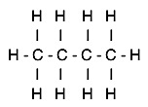

**2 + 13 O2 🡪 8 CO2 + 10 H2O** (or mole ratio 1, 6.5, 4, 5)

(b) Ethene reacting with chlorine. (2 marks)

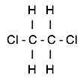

**+ Cl2 🡪**

(c) Pentene reacting with HI in the presence of a platinum catalyst. (2 marks)

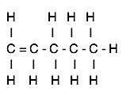

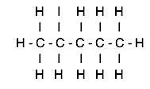

**+ HI 🡪**

**Question 35 (13 marks)**

The properties of metallic, ionic, covalent molecular and covalent network substances can differ dramatically. As a result they are used for different purposes. With reference to chemical structure, account for the following scenarios:

(a) Iron can be bent into shapes while iron (II) chloride cannot. (6 marks)

* **Iron has metallic bonding.**
* **It is made up of positive ions (cations) and sea of delocalised electrons.**
* **When a force is applied both the ions and delocalised electrons move as the bonding is non-directional so no repulsion is experienced.**
* **Iron (II) chloride has ionic bonding.**
* **It has a fixed 3D lattice made up of positive and negative ions.**
* **When a force is applied ions of similar charge line up and repel each other.**

(b) The differences in melting points of SO2 and SiO2. (4 marks)

**SO2**

* **Has covalent molecular bonding.**
* **It has weak intermolecular forces and therefore does not require much heat to disrupt the forces, resulting in a low melting point.**

**SiO2**

* **Has covalent network bonding.**
* **It has strong intramolecular forces which require large amount of heat to break the bond, resulting in a high melting point.**

(c) Aluminium conducts electricity more efficiently than sodium. (3 marks)

* **Aluminium has three delocalised electrons per positive ion.**
* **Sodium has one delocalised electron per positive ion.**
* **As aluminium conducts electricity more efficiently because it has more charged particles.**

**Section Three: Extended answer (80 marks)**

**Question 36 (5 marks)**

Morphine (C17H19NO3) is an opiate type of medication that is used for chronic pain. German pharmacists Freidrich Serturner was the first to derive morphine from the plant, opium poppy, in early 1800’s. It is used for serious injuries, after operations and sometimes given during childbirth. It is a highly addictive medication that can cause drowsiness and vomiting.

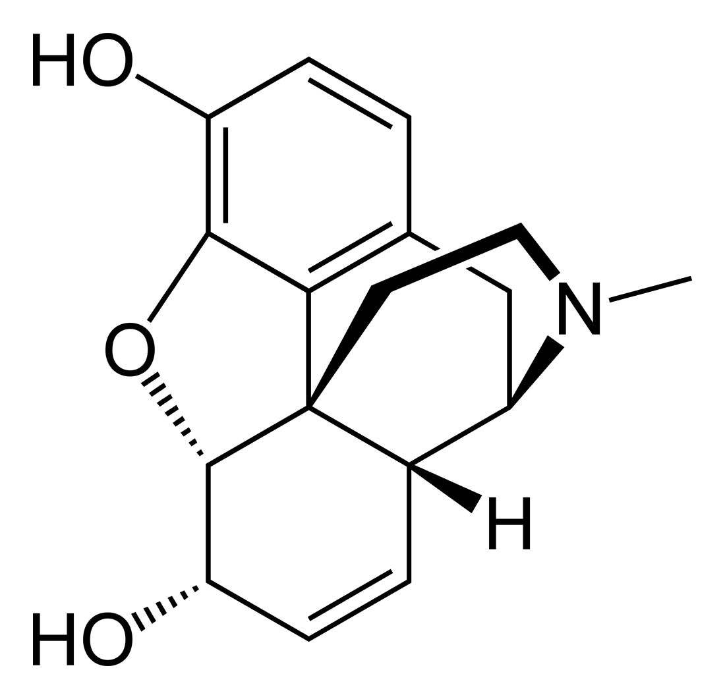

Calculate the percentage composition of morphine.

**M(C17H19NO3) = (12.01 x 17) + (1.008 x 19) + (14.01 x 1) + (16.00 x 3) = 285.33**

**C% = M(C) ÷ M(C17H19NO3) x 100**

**C% = 204.14 ÷ 285.33 x 100**

**C% = 71.55%**

**H% = M(H) ÷ M(C17H19NO3) x 100**

**H% = 19.152 ÷ 285.33 x 100**

**H% = 6.71%**

**N% = N(H) ÷ M(C17H19NO3) x 100**

**N% = 14.01 ÷ 285.33 x 100**

**N% = 4.91%**

**O% = M(O) ÷ M(C17H19NO3) x 100**

**O% = 48.00 ÷ 285.33 x 100**

**O% = 16.82%**

**Question 37 (11 marks)**

Magnesium carbonate is added to phosphoric acid to form a colourless odourless gas.

(a) Balance the equation below. (1 mark)

**3**MgCO3(s) + **2**H3PO4(aq) 🡪 Mg3(PO4)2(s) + **3**H2O(l) + **3**CO2(g)

If an excess amount of phosphoric acid is added to 2.75 gram of magnesium carbonate calculate:

(b) The amount of phosphoric acid consumed in moles. (3 marks)

* **M(MgCO3) = 84.32**
* **n(MgCO3) = m ÷ M = 2.75 ÷ 84.32 = 0.0326 mol**
* **n(H3PO4) = 0.0326 x 2/3 = 0.0217 mol**

(c) The amount of magnesium phosphate in grams. (3 marks)

* **n(Mg3(PO4)2) = 0.0326 ÷ 3 = 0.01086 mol**
* **M(Mg3(PO4)2) = 262.87**
* **m(Mg3(PO4)2) = n x M = 0.01086 x 262.87 = 2.85 g**

(d) The total number of molecules of gas produced. (2 marks)

* **n(CO2) = n(MgCO3) = 0.0326 mol**
* **N(CO2) = n x 6.022x1023 = 1.96x1022 molecules**

(e) The total number of formula units of magnesium phosphate produced. (2 marks)

* **n(Mg3(PO4)2) = 0.01086 mol**
* **N(Mg3(PO4)2) = n x 6.022x1023 = 6.54x1021 formula units**

**Question 38 (12 marks)**

Within the human body certain types of reactions known as oxidation reactions produce harmful products that can lead to diseases. It has been suggested that certain chemicals found in foods can prevent these reactions occurring. These beneficial chemicals are therefore called antioxidants and can come in a variety of fruits and vegetables. Common antioxidants include vitamins A, C and E and are found in food such as carrots, blueberries, grapes, cranberries and sweet potato.

To determine the content of antioxidants in a particular food, the Briggs-Rauscher reaction is used. This is an oscillating chemical reaction that produces vivid colour changes. It starts at a dark blue colour and changes to colourless then yellow and back to dark blue. The time taken to complete one cycle of colour changes can determine the concentration of antioxidant in the food. The longer the time it takes for one cycle the more antioxidants the food will contain.

Below is a table of result from a student’s investigation:

|  |  |  |  |  |
| --- | --- | --- | --- | --- |
| **Food** | **Trial 1**  **(seconds)** | **Trial 2**  **(seconds)** | **Trial 3**  **(seconds)** | **Average (seconds)** |
| Carrots | 73 | 70 | 77 | **73.3** |
| Blueberries | 289 | 296 | 227 | **270.7** |
| Grapes | 84 | 93 | 89 | **88.7** |
| Cranberries | 99 | 100 | 96 | **98.3** |
| Sweet potato | 160 | 159 | 166 | **161.7** |
| Kale | 205 | 208 | 203 | **205.3** |

(a) Calculate the average time for each type of food. (3 marks)

**Carrots: (73 +70 +77) ÷ 3 = 73.3**

**Blueberries: (289 +296 +227) ÷ 3 = 270.7**

**Grapes: (84 +93 +89) ÷ 3 = 88.7**

**Cranberries: (99 +100 +96) ÷ 3 = 98.3**

**Sweet potato: (160 +159 +166) ÷ 3 = 161.7**

**Kale: (205 +208 +203) ÷ 3 = 205.3**

(b) Which food would have the highest level of antioxidants? (1 mark)

**Blueberries**

(c) Identify the independent variable. (1 mark)

**Food type**

(d) Identify the dependent variable. (1 mark)

**Time**

(e) Identify one controlled variable that would need to be taken into account. (1 mark)

**Same amount of food.**

Claims have been made that the concentration of antioxidants decreases when the food is cooked. This results in less antioxidants been consumed in order to stop oxidation reactions within the body.

The student ran the same investigation again, using the Briggs-Rauscher reaction, but with cooked samples of each type of food. The student’s results were collected.

|  |  |
| --- | --- |
| **Food** | **Average**  **(seconds)** |
| Carrots | 72 |
| Blueberries | 251 |
| Grapes | 85 |
| Cranberries | 80 |
| Sweet potato | 163 |
| Kale | 205 |

(f) Consider the information given and evaluate the claim that, “the concentration of antioxidants decreases when the food is cooked.” (5 marks)

* **Blueberries and cranberries went down significantly (most affected).**
* **Blueberries went down by 19.7 seconds while cranberries went down by 18.3.**
* **Carrots, grapes and kale were roughly the same (appeared unaffected).**
* **Sweet potatoes went up which is unexpected.**
* **The statement is only valid for the berries.**

**Question 39 (18 marks)**

Fossil fuels such as coal and oil have played a major role in sustaining our energy needs. However these fuels are starting to become limited in supply and over recent times have been linked to environmental issues such as global warming.

Biofuels are an alternative form of energy that includes bioethanol, biogas and biodiesel. The production of bioethanol has started to occur in Australia. Bioethanol relies on the fermentation of crops (sugarcane, wheat or corn) to enable energy to be obtained.

For the production of bioethanol to occur, large numbers of these food crops need to be planted. Farmers are now using substantial amounts of fertilisers to improve their crops yield. These fertilisers are high in chemical elements that enable plants to grow faster. This has led to problems associated with run-off that causes eutrophication and can result in algal blooms and fish dying.

Scientists from the Environmental Protection Authority collected a sample of water from a river that passes through a farm, which is known to grow corn for biofuels, after reports of fish dying in large numbers. It was tested using mass spectroscopy and the results shown below.

1. Determine the three elements that have resulted in the fish death, by calculating their relative

* **(14 x 98 ÷ 100) + (15 x 2 ÷ 100) = between 13.73 and 14.02**
* **This will be nitrogen.**
* **(30 x 8 ÷ 100) + (31 x 87 ÷ 100) + (32 x 5 ÷ 100) = between 30.36 and 30.97**
* **This will be phosphorus.**
* **(39 x 93 ÷ 100) + (40 x 6 ÷ 100) + (41 x 1 ÷ 100) = between 38.69 and 39.08**
* **This will be potassium.**

(b) Explain why the relative molecular mass of each element is not identical to those found on the periodic table. (2 marks)

* **As these are isotopes of each element.**
* **Isotopes have different atomic mass/ number of neutrons.**

(c) Give two advantages of using biofuels. (2 marks)

**Any two**

* **Renewable resource.**
* **Does not take very long to grow crops.**
* **Classified as being carbon neutral as carbon is recycled from the atmosphere.**
* **Produces very low sulfur levels which leads to less environmental hazards such as acid rain.**
* **Cost less than petrol at the tank.**
* **Creates more jobs.**
* **Economic stimulation to the agriculture industry.**

(d) Give two disadvantages of biofuels that has not been discussed in this paper. (2 marks)

**Any two**

* **Lower energy output.**
* **Expensive to set up.**
* **Uses fossil fuels in the process of making biofuels.**
* **Cost of food could increase due to demand and limited supply.**
* **Increased water use for the crops.**
* **Damage to natural forest for crops to be grown.**

(e) Describe each of the following steps of mass spectrometry.

(i) Ionisation (2 marks)

* **The atoms are ionised by using an electron beam to knock one or more electrons off, creating a positive ion (mostly +1).**
* **This must occur in a vacuum chamber.**

(ii) Acceleration (1 mark)

* **The ions are accelerated so that they all have the same kinetic energy. This is achieved by using an ion accelerator or an electric field.**

(iii) Deflection (3 marks)

* **The ions are then deflected by a magnetic field.**
* **The lighter they are, the more they are deflected and travel in smaller circles (smaller radius).**
* **The amount of deflection also depends on the number of positive charges. More charged, more deflected.**

**Question 40 (9 marks)**

Nanotechnology is an emerging area of scientific endeavour. Much of the development in the field has been due to advances in high powered microscopy. One such microscope is the scanning tunnelling microscope, which owes its existence to scientists Gerd Binnig and Heinrich Rohrer who made their discovery known in 1981. Some of the more well-known nanomaterials owing their discovery to Binning and Rhorer’s work are buckminsterfullerene (bucky ball) and carbon nanotubes.

(a) Define the term nanoparticle. (1 mark)

* **Nanoparticles are defined as particles between 1 and 100nm.**

(b) How do nanoparticles differ from their bulk material? (2 marks)

* **They have larger surface area to volume ratio.**
* **This makes them more reactive.**

(c) With the use of a diagram, explain how nanoparticles have helped with UV protection in sunscreens. (4 marks)

**Sunscreens with nanoparticles**

* **The nanoparticles are distributed evenly on the skin, when UV rays hit them the UV is absorbed causing them to be scattered away.**

**Sunscreens without nanoparticles:**

* **As a result of the particle size, the particles are distributed unevenly, this can result in UV light passing through to the skin.**

|  |  |
| --- | --- |
| Sunscreen **without** nanoparticles: | Sunscreen **with** nanoparticles: |

(d) Describe one concern that people may have with the use of nanoparticles in sunscreens. (1 mark)

* **Nanoparticles may be absorbed by human skin and may lead to unknown side effects.**

(e) Give another example, which has not already been discussed in this paper, where nanoparticles are being used to benefit society in some way. (1 mark)

**One of the following:**

* **Antibacterial and/or antifungal nano-silver bandages.**
* **Antibacterial children’s toys.**
* **Antibacterial socks.**
* **Self cleaning windows.**
* **Water repellent fabrics.**
* **Sports equipment for its strength and low in weight.**
* **Scratch resistant cars bodies.**

**Question 41 (11 marks)**

Sodium’s eleven ionization energies are listed below.

|  |  |
| --- | --- |
| **Number of electrons** | **Ionisation energy / kJ molL-1** |
| 1 | 496 |
| 2 | 4,562 |
| 3 | 6,910 |
| 4 | 9,543 |
| 5 | 13,354 |
| 6 | 16,613 |
| 7 | 20,117 |
| 8 | 25,496 |
| 9 | 28,932 |
| 10 | 141,362 |
| 11 | 159,075 |

(a) Graph these results. (5 marks)

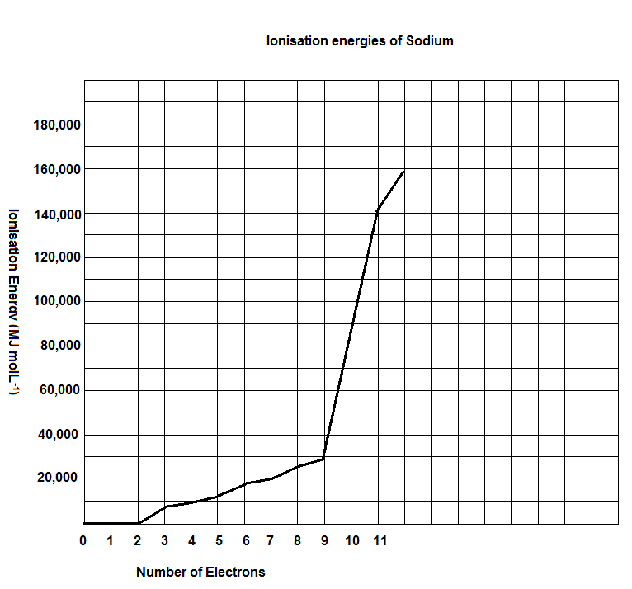

* **Title**
* **Labelled axes**
* **Units**
* **Points plotted correctly**
* **Scale**

**(Accept line and column graph)**

(b) Describe the trends that occur in the graph. (2 marks)

* **States gradual increase between 3-9**
* **Sudden increases at 2 and between 9-10.**

**(If students do not get the increase at 3 still give the mark)**

(c) Explain why these trends are occurring. (4 marks)

**Gradual increase**

* **Electrons are being removed from the same energy shell.**
* **Nucleus is becoming more positive.**

**Sudden increase**

* **Electrons are being removed from energy shells that are closer to the nucleus.**
* **This requires large amounts of energy to remove as the nucleus increasingly positive.**

**Question 42 (6 marks)**

Good Friday has a common tradition where people will eat seafood during the festive period. Gary, a local fishmonger, has had complaints from his customers after they became ill from eating the swordfish he sold to them. With his reputation being questioned, Gary decides to get the batch of swordfish tested using atomic absorption spectroscopy (AAS).

Analytical chemists compared the swordfish sample against known spectra. Analyse the information below and answer the associated questions.

**Arsenic:**



**Mercury:**



**Lead:**



**Swordfish Sample:**



(a) Was the swordfish to blame for the customers’ illness? Give a reason for your answer.

(2 marks)

* **Yes**
* **Swordfish sample has similar light emissions to mercury.**

(b) Explain how a flame test works. (4 marks)

* **When a substance is heated to a high temperature, electrons absorb energy and jump from their ground state energy levels to higher energy levels to form excited atoms.**
* **A photon of light is released as energy is emitted.**
* **This light is specific to each element.**
* **Electrons go back to their ground state energy levels within nanoseconds of being heated.**

**Question 43 (4 marks)**

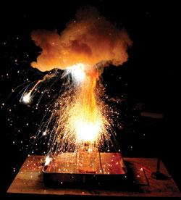The thermite reaction is a highly exothermic reaction that produces large amounts of energy in the form of heat and light. The reaction occurs between aluminium and iron (III) oxide to form iron and aluminium oxide as per the equation:

2Al + Fe2O3 → 2Fe + Al2O3.

As temperature can exceed 2200oC many safety risks need to be taken into account.

Conduct a risk assessment of this experiment, by suggesting two potential risks and outline ways to reduce the identified hazards.

**Risk 1:**

* **Emits large amounts of light that can damage eyes.**

**Reducing Risk (any one of the following)**

* **Ensure that all viewers are wearing safety glasses.**
* **Do not look directly at the flame.**
* **Person conducting the demonstration should wear a face shield.**

**Risk 2:**

* **Emits high temperatures that could start other spot fires.**

**Reducing Risk (any one of the following)**

* **Viewers should be 5 metres away from the demonstration.**
* **All viewers and demonstrator should be wearing lab coats.**
* **Demonstrator should be wearing gloves.**
* **Have a fire extinguisher in case of flying sparks initiates other fires.**

**Question 44 (4 marks)**

Findings from a range of scientific experiments have contributed to the understanding of the atom.

Some of the most well-known scientists that have contributed to the Atomic Theory have been Joseph John Thomson in the late 1890’s and his successor Ernest Rutherford in the early 1900’s.

For one of these scientists:

(a) Describe the experiments they conducted that lead to their discovery. (1 mark)

(b) The conclusions they made about the atomic structure as a result of their findings.

(3 marks)

**(a) Thomson:**

* **Cathode rays pass through a Cathode Ray Tube that contained charged metal plates.**

**(b) Thomson:**

* **He found that the cathode ray went towards the positive metal plate.**
* **He came up with the theory of the “Plum Pudding” model.**
* **This theory stated that small electrons imbedded within a sphere of uniformly positive**

**charged mass.**

**OR**

**(a) Rutherford:**

* **He beamed alpha particles through a thin sheet of gold foil.**

**(b) Rutherford**

* **Most of the beams went through but a small number deflected or bounced back.**
* **Atoms consist of empty spaces that are occupied by electrons.**
* **Electrons orbit a nucleus where protons are found.**